CHRONOS SELF IMPROVEMENT DOC/DISCUSSION

Yes I want to run set 5 when those numbers come in I will provide them to you. For now, let's get back to feature building and issue resolution.
A long-term goal for this tool is to evolve into an automated prediction and bidding engine. The future state is for it to make trades/bets/wagers/ autonomously via Kalshi based on the readings from the prediction engines. It should run while I sleep. And I want to be able to set rules like spending limits and spending units and when to break the rules to spend more or less in special circumstances learned over time. Based on where we are now, How feasible is it that we achieve this goal?
Show less
6:35 PM
Weighed feasibility of autonomous trading system architecture
Weighed feasibility of autonomous trading system architecture
This is achievable, and you're closer than you might think. Let me give you an honest breakdown.
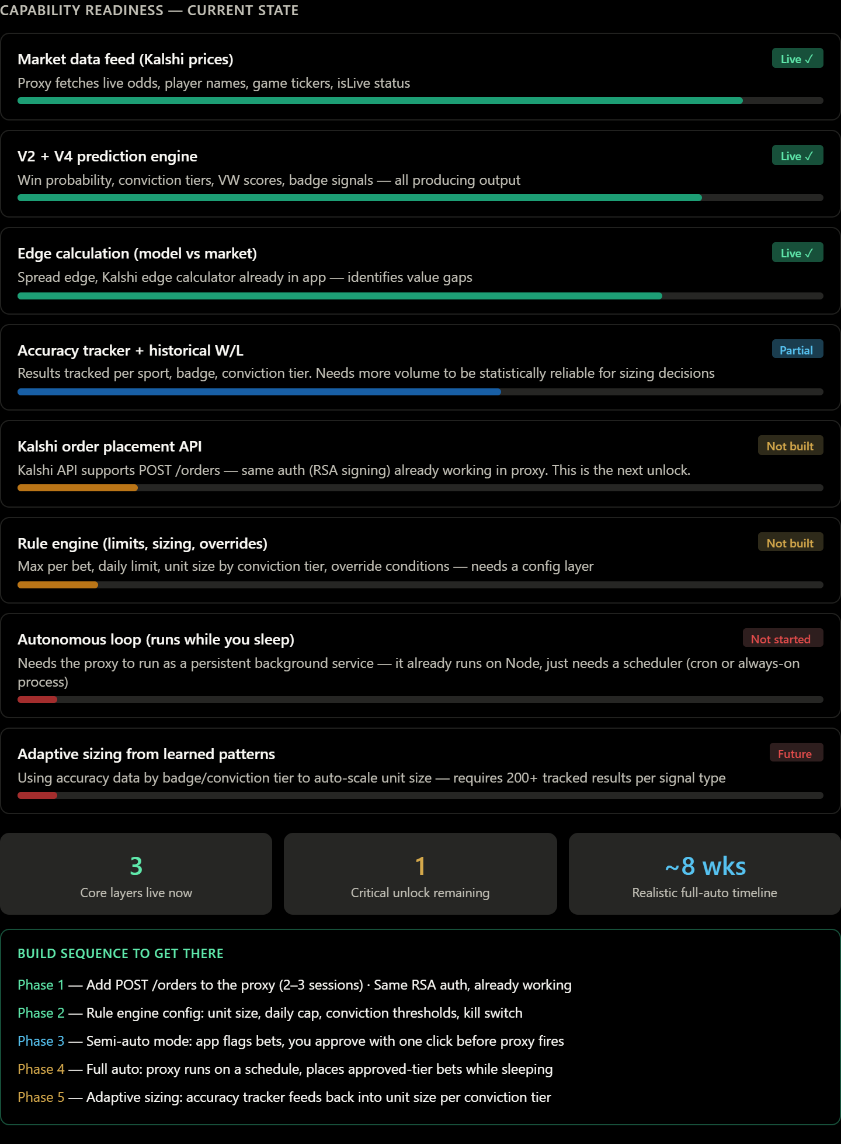
The honest answer: highly feasible, and the hardest part is already done.
The prediction intelligence, market data feed, and edge calculation all exist and are producing live output. The only true blocker is one API call — POST /orders to Kalshi. The RSA signing auth that unlocks it is already working in your proxy. That's the unlock that makes everything else possible.
The critical piece before full automation is Phase 3 — semi-auto mode. Before you let it run while you sleep, you want a period where it asks before it acts. One-click approval through the app teaches you where the engine is overconfident, which badge tiers are ready to trust, and what edge threshold is worth betting. That feedback loop is what makes the eventual autonomous rules actually calibrated rather than guessed.
On the rule engine specifically — the architecture you described (units, limits, special-circumstance overrides) maps cleanly onto what's already tracked: conviction tier, badge type, sport, time of day, agreement between V2 and V4. Those can all become multipliers and gates. The accuracy tracker is already building the dataset needed to set those thresholds empirically rather than arbitrarily.
One real constraint to name: Kalshi's API terms. Their developer agreement governs automated trading. You'll want to review that before Phase 4 goes live — not because it's likely a blocker, but because knowing the rules lets you build within them confidently.
When you're ready to start on Phase 1, that's a focused proxy session — add the order endpoint, test with small amounts in paper mode, then wire a "Place Bet" button into the tennis and game cards that goes through the proxy.
Well as a project manager I'm going to hold you to that schedule and level of effort you've reported. But to be honest I'm not really pleased with the functionality and stability of our Kalshi integration so far. To me, it's not stable and it makes me nervous to put full trust in it to make trades for us at a later date. So we definitely need to work the kinks out to make it a much better integration.
I also feel like we have more work to do on the prediction engines. We're doing well in some sports but to be a house for all sports will mean we need to dig deeper into the winner's algorithm and ensure we are right in step with it. My aim is to be at 90-100% accuracy/hit rate but no less than 85%. Right now we are barely over 60%. The good news is we are just started to gather rich data and once are reports and summaries have the amount of data we need, we cand adjust our rules and develop new metrics to measure.
2 conversations that we need to have to bring us closer to the 90% accuracy rating pre-game are v2/v4/vegas tuning for alignment and a self-improvement engine. I truly believe once we get those two discussed and finalized that will drive our accuracy up at least 20%.
V2/V4/Vegas : It starts with v2 and v4. We need to tighten our ship on the initial v2 and v4 predictions because they shouldn’t disagree as much as they do. Give me some options where we can improve our logic and formula to make v2 and v4 more accurate and aligned. That way when they do disagree we know we have more deep diving to do.
Self-improvement engine - This is a huge requirement with heavey rewards if you done efficiently. "If we build it, they will come" mode here. We have to lock our system into an improvement cycle that leads us to the autonomy that I spoke about earlier. It will start thinking for itself.
Show more
6:58 PM
Architected alignment strategies and autonomous learning framework
Architected alignment strategies and autonomous learning framework
Two of the most important conversations we can have. Let me give you a full strategic breakdown of both before we start coding anything — because these decisions shape architecture, not just features.
Why V2 and V4 disagree — root causes

The most important thing I can tell you on V2/V4 alignment:
Don't try to force them to agree more often — that's the wrong goal. They're built on fundamentally different paradigms, and their disagreements are actually information. The right goal is to know which one to trust when they disagree, and to only act when both are confident. Right now the app acts on 50% WP predictions. That's a coin flip. Raising V2's action floor to 60% and V4's action floor to 85% is the single highest-leverage change you can make right now, before any new code is written.
On the self-improvement engine — the good news is you're already collecting everything it needs. The accuracy tracker stores conviction tier, badge type, sport, V4 pick, V2 pick, Vegas line, and outcome. That's the complete dataset. The engine is essentially a scheduled query against that data that scores each signal and adjusts weights. It's not machine learning — it's analytics with a feedback loop. That's important because it's interpretable: you can always see why a threshold changed and override it.
The path to 85%+ is sequential, not simultaneous. Step one is raising the confidence floors so you stop tracking low-conviction predictions as actionable. Step two is letting volume accumulate. Step three is the weight table. Each step feeds the next.
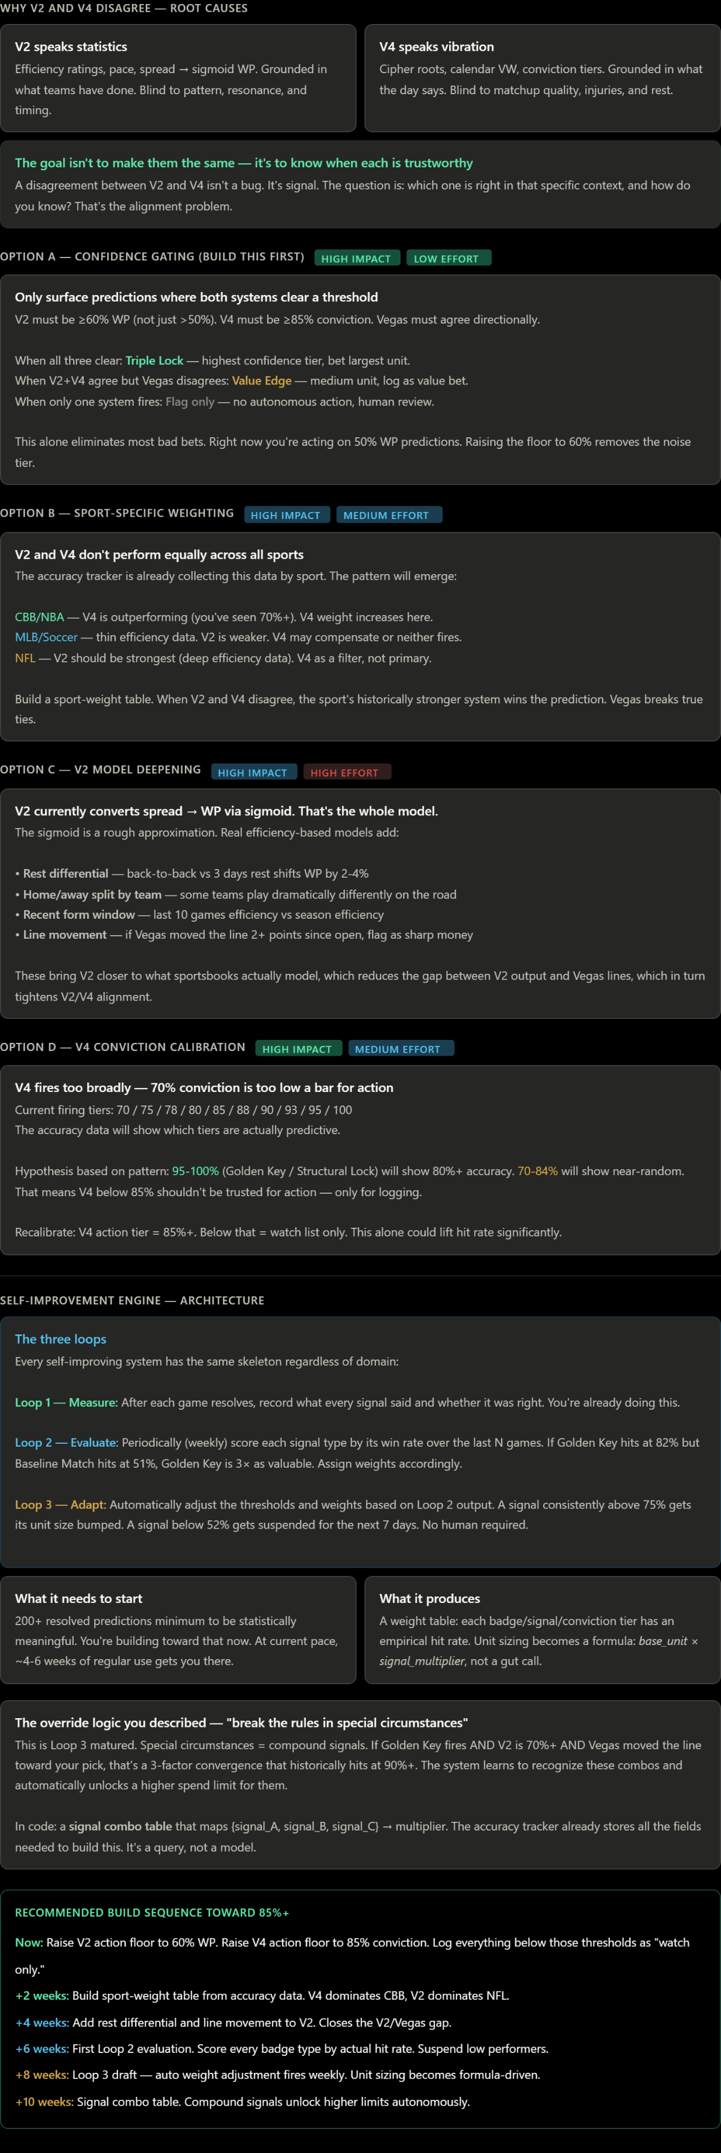
Which piece do you want to start building first — the confidence floor changes are a quick coding session, or do you want to design the Loop 2 evaluation engine architecture first?

